**COMPUTER VISION BASED PARKING SPACE DETECTION**

GUIDE: Mrs.Prof.Preeti

School of Engineering

Computer Science – AI&ML

Malla Reddy University , Hyderabad, India

Tialu Manikanta

Computer Science – AI&ML

Malla Reddy University , Hyderabad, India.

[2211cs020509@mallareddyuniversity.ac.in](mailto:2211cs020509@mallareddyuniversity.ac.in)

Vavillapally Ashrith

Computer Science – AI&ML

Malla Reddy University , Hyderabad, India.

[2211cs020529@mallareddyuniversity.ac.in](mailto:2211cs020509@mallareddyuniversity.ac.in)

Vindekoti Ganesh

Computer Science – AI&ML

Malla Reddy University , Hyderabad, India.

[2211cs020537@mallareddyuniversity.ac.in](mailto:2211cs020537@mallareddyuniversity.ac.in)

Kasireddy Hima Bindhu

Computer Science – AI&ML

Malla Reddy University , Hyderabad, India.

[2211cs020573@mallareddyuniversity.ac.in](mailto:2211cs020573@mallareddyuniversity.ac.in)

Vishal Dev Kumar

Computer Science – AI&ML

Malla Reddy University , Hyderabad, India.

2211cs020575@mallareddyuniversity.ac.in

# ABSTRACT

A new system is presented to detect the empty spaces available for parking between vehicles. To detect the parking space, this system combines information coming from an ultrasonic sensor and a 3D vision sensor. The profiles of parked vehicles are modelled by a couple of vertical planes: a longitudinal plane and a lateral plane. The empty space between profiles is the detected parking space. Longitudinal planes are computed with ultrasonic data while lateral planes are obtained from 3D vision data. Experimental evaluations validated the approach and showed a positioning accuracy below 10cm and a length accuracy below 20cm.

# INTRODUCTION

The main objective of our research is to provide a surroundings monitoring system to support car drivers in avoiding collisions. To achieve this goal, 3D computer vision technologies have been selected because they allow to:

* detect and localize obstacles,
* provide the driver an easy to understand 3D representation of the surrounding scene.

We have already presented in (1) and (2) two different algorithms that were developed for this purpose. Their ability to detect static and moving obstacles from a single camera on board of a vehicle was proved.

In addition to realize surroundings monitoring, we wanted to determine how to extend the functionalities of the system. We wanted to show that 3D vision and ultrasonic sensing technologies could mutually complement each other to detect and localize the parking space.

Indeed, in the recent years, the function of automatic parking maneuver has been a major application. Toyota currently proposes an Intelligent Parking Assist system that uses two side ultrasonic sensors to detect the parking space and to automatically perform parking maneuvers (3). Other parking systems detect the parking space using white line detection techniques (4)-(8).

This paper presents a different approach for automatic parking space detection. It is based on the combination of ultrasonic data and 3D vision data in order to model the parked vehicles in the scene and detect, locate and measure the parking space. The outline of the system and the technology involved are presented in section 2. Algorithms are presented in section 3. Section 4 provides results for both parallel and back-in parking situations. The last two sections conclude about the system and present future actions.

# DESCRIPTION OF THE SYSTEM

This section first presents the targets, the conditions of usage and the setup of the system. Next, it presents the technologies involved in it. As our parking space detection system has been built on top of our 3D static obstacle detector, this static obstacle detector is presented, followed by the parking space detector.

## TARGETS, CONDITIONS OF USAGE AND SETUP

The targets of the system are shown in Figure 1, the conditions of usage in Table 1.

The parking space to be detected is defined as the empty space located between two vehicles parked on the side of the road. Our vehicle is moving forward along the two parked vehicles. The first encountered vehicle is called *the vehicle A*, the second encountered vehicle is called *the vehicle B*. Two parking configurations must be handled: parallel parking (vehicles parked parallel to the road) and back-in parking (vehicles parked orthogonally to the road).

The system must detect the parking space when our vehicle is stopping after vehicle B. The system must be able to accurately localize the parking space and measure its length: the corners of vehicle A and vehicle B must be located with 10cm accuracy; the parking space length must be given with 20cm accuracy. Such accuracy is sufficient to compute the parking trajectory and easily park in a narrow space.

|  |  |  |
| --- | --- | --- |
| **Conditions of usage** | | **Comments** |
| Lighting | The minimum brightness allowed by camera. | Special attention to worst  cases should be given (night, dark vehicles, …). |
| Supposed  situations | Parallel and back-in  parking. | Back-in = Pocket . |
| Objects to  detect | Different kinds of parked  vehicles. | Obstacles must be static. |
| Driving conditions | Max speed: 15 km/h |  |
| Moving vehicle is between [0.3,2]m away  from the obstacles. | Minimum and maximum sensing distances of the  ultrasonic sensor. |
| Only moving in forward direction. | The parking space must be detected when stopping after  vehicle B. |

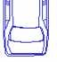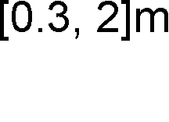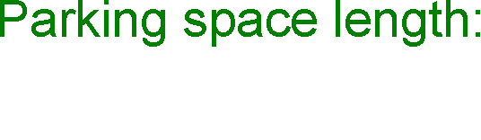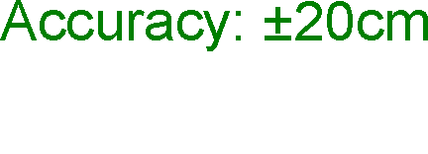

Figure 1: Detection targets (in parallel parking).

Table 1: Conditions of usage.

The system setup is shown in Figure 2. Our vehicle is equipped with an onboard PC, a rear- view camera, ABS sensors and an ultrasonic sensor installed at the left side of the front bumper.

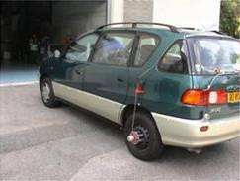

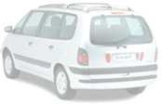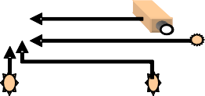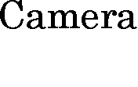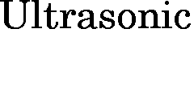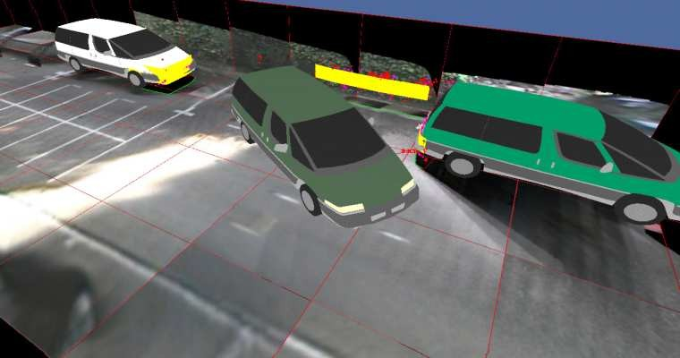

Figure 2: Prototype setup.

## STATIC OBSTACLE DETECTION

To address the functions of *obstacle detection*, *vehicle to obstacle distance measurement*, and *collision warning*, we proposed in (1) a technology that can reconstruct in 3D the surrounding environment. This technology uses images taken at different viewpoints along the trajectory as input. This approach depends on core technologies such as camera calibration, odometry, point tracking, 3D modeling, and 3D filtering. It uses the triangulation principle to reconstruct 3D points onto the obstacles. These points must be tracked in at least 2 different images *assuming* that obstacles are *static in the scene.* The 3D points on the obstacles are then filtered to keep only the best. Eventually, the obstacles are modeled from the 3D points to provide the above mentioned functions.

This 3D vision sensing approach relies on the presence of points to track. Unfortunately, due to the uniform appearance of vehicle sides, sometimes only few 3D points are available in these regions. On the contrary, more 3D points are usually available in the front and back regions of vehicles where many visual features can be found (headlamps, license plate, bumpers…). Consequently the reconstructed 3D shape of the obstacles is sometimes not representative enough (e.g. the side of a car may be represented by 2 separated parts located around the 2 wheels of a vehicle), which makes difficult the robust detection of the empty space located between two parked vehicles.

## PARKING SPACE DETECTION

To address the function of *parking space detection and localization*, we have chosen to model the vehicles A and B parked on both sides of the parking space by their *profile*. A profile is an approximation of the vehicle shape by its *longitudinal* and *lateral planes*. The longitudinal plane is approximating the side of the parked vehicle which is parallel to the road direction; the lateral plane is approximating the side of the parked vehicle which is orthogonal to the road direction (see Figure 1 for an illustration). Then, the desired parking space is the empty space located between the profiles of the vehicles A and B.

To compute the profiles of the parked vehicles, we have chosen to combine the information coming from the ultrasonic sensor with the information coming from our 3D vision sensor (more precisely the 3D point reconstruction module of our static obstacle detector).

To provide the longitudinal planes of the parked vehicles, the ultrasonic sensor is used. As our vehicle moves, the ultrasonic sensor gives the distance to the parked vehicles. The knowledge of our vehicle ego-motion (odometry) and this distance enables to determine the longitudinal planes of the parked vehicles. The position and orientation of these planes are accurately estimated but not their extremities. Indeed the ultrasonic information is accurate as long as the reflecting surface is orthogonal to the direction of the ultrasonic sensor. This is not the case of the extremities of the parked vehicles (most of the vehicles have now rounded front and rear surfaces). In (3) a method has been proposed to correct the data in these regions. We have decided to follow another approach: we will use our 3D vision sensor because of its ability to reconstruct many 3D points in the front and rear regions of vehicles.

The vision sensor is used to reconstruct 3D points in the extremities of the parked vehicles. The clouds of reconstructed 3D points are next approximated into planar surfaces: the lateral planes. These planes are constrained to be orthogonal to the longitudinal planes. They intersect the longitudinal planes and this intersection defines their new extremities. These extremities are much better localized than with non-corrected ultrasonic data alone.

When looking at the performances of both ultrasonic and vision sensors, it strongly appears that they have the potential to mutually complement each other to build the parked vehicle profiles and detect the parking space. The algorithm presented in the next section was developed to cope both with the imprecise ultrasonic data on the parked vehicle extremities and the lack of 3D shape relevancy of the vision sensor on the parked vehicle sides.

# PARKING SPACE DETECTION ALGORITHM

The algorithm for parking space detection is divided into three parts. First longitudinal planes are computed for the parked vehicles. Next lateral planes are computed for the parked vehicles. Longitudinal and lateral planes are combined into profiles and the parking space is searched between the reconstructed profiles.

## LONGITUDINAL PLANE COMPUTATION

Knowing the 3D position of the ultrasonic sensor thanks to the odometry, the ultrasonic distance information is converted into 3D points (blue dots in Figure 4). The raw ultrasonic distances are used (there is no correction such as in (3)). Ultrasonic 3D points are clustered into independent sets which are approximated by vertical planes (blue planes in Figure 4), the longitudinal planes. The clustering of the ultrasonic points and the plane estimation are iterative processes which are executed each time a new point is acquired. As shown in Figure 4, the longitudinal planes attached to parked vehicles are, at this stage, too long to locate the real extremities of the parked vehicles. The estimates of these extremities are refined afterwards by computing the lateral planes (they will cut the longitudinal planes and restrict their length).

## LATERAL PLANE COMPUTATION

The lateral plane attached to a parked vehicle is computed by fitting a vertical plane to the cloud of 3D points reconstructed by the vision sensor at the extremity of the vehicle. As shown in Figure 3 and Figure 4, 3D boxes (grey boxes) are created. They are aligned with the extremities of the longitudinal planes. They are used as 3D regions of interests. Only the vision 3D points inside these boxes (green dots) are used to estimate the lateral planes (orange planes). The lateral plane is constrained to be orthogonal to its associated longitudinal plane. Finding the lateral plane reduces to finding its position along its longitudinal plane. A histogram is computed to analyze the distribution of the vision 3D points along the longitudinal plane (see Figure 3). The lateral plane is the one corresponding to the most relevant mode in this distribution.



Longitudinal

X

0 plane

0

X

3D points

Lateral plane

Bounding box

Position of the lateral plane



4

2 2

1

Number of 3D points Number of 3D points

0 0 X



4

3

1 1

1

X

Figure 3: Lateral plane fitting procedure.

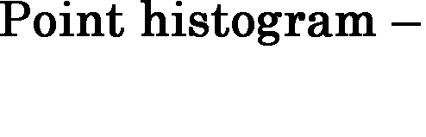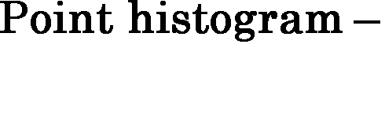

## PARKING SPACE COMPUTATION

For a parked vehicle, the longitudinal and lateral planes computed as above constitute its *profile*. The parking space between two parked vehicles is defined as the empty space located between the profiles of the vehicles (dotted green rectangle in Figure 4). The corners of the profiles provide the localization of the parking space; the distance between these corners provides the length of the parking space. By comparing this length with our vehicle length, the detected parking space is declared good for parking or not. If it is good, then a target parking space is set in the middle of the empty space (plain green rectangle in Figure 4).

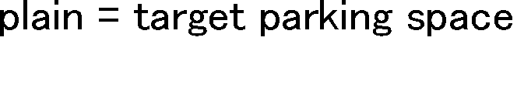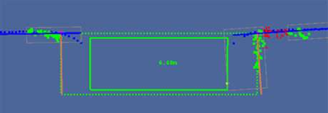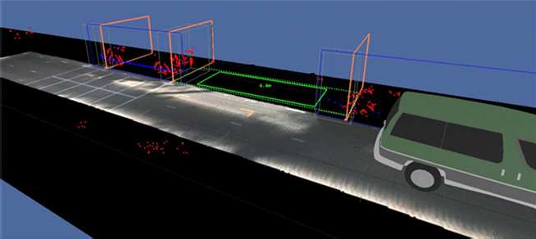

Figure 4: Contribution of the different components involved in parking space detection

The system is also able detect an available parking space even if only the profile A has been detected. Indeed as soon as a longitudinal plane is computed (the one belonging to the profile A), the system starts to compute the empty space between the end of the plane and the current car location. When the lateral plane of the profile A is computed (as soon as 3D points are provided by the vision sensor), the length of the longitudinal plane is modified and the localization and length of the empty space are updated.

# PARKING SPACE DETECTION RESULTS

Our Parking Space Detection has been experimentally evaluated with several parking sequences for both parallel and back-in parking configurations in daylight illumination conditions (see Figure 5 for examples).

|  |  |  |  |
| --- | --- | --- | --- |
| Parking  configuration | Acquired image | 3D virtual view  (perspective view) | 3D virtual view  (top view) |
| Parallel |  |  |  |
| Back-in |  |  |  |

Figure 5: Examples of parking configurations and their associated results.

The results of these evaluations are the following:

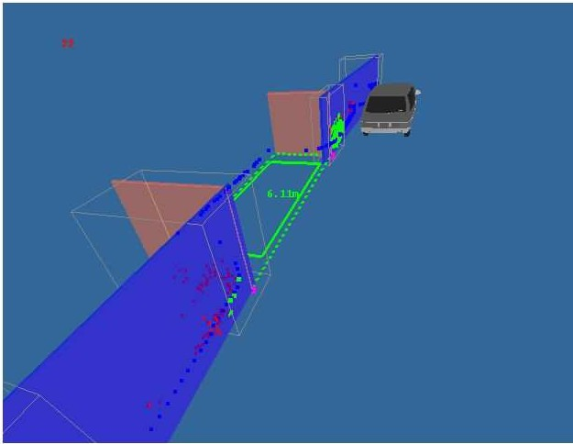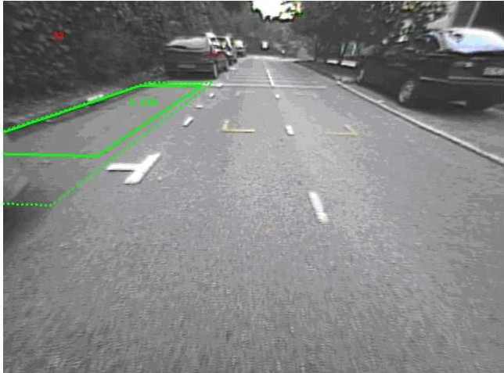- In most of the situations the parking space was successfully detected. An example of result is given in Figure 6.

**Blue plane**: longitudinal plane from ultrasonic data

**Orange plane**: lateral plane from 3D sensor **Green rectangle**:

detected parking space

Legend 3D virtual view Back-projection in acquired image Figure 6: Results displayed by IMRA onboard system.

* To evaluate the accuracy of the parking space localization, we evaluated the position

accuracy of the corners of the profiles A and B. This was done by comparing the estimated distance between the reconstructed corners and the camera centre with respect to the ground truth provided by a laser telemeter. The average error was below 8cm for each corner.

* To evaluate the accuracy of the parking space length estimation, we compared the estimated length separating the corners of the profiles A and B with respect to the ground truth provided by a laser telemeter. The average error was below 16cm.
* The parking space location and dimensions obtained with the combined ultrasonic-vision system are 10 to 50cm better than with the ultrasonic system only.
* Failure came mostly from the lack of robustness of the ultrasonic data processing step (longitudinal plane computation). Two example of the major causes of failures are given below:
  + It was found that when the parked vehicles are located at about 2m, the ultrasonic raw data were too noisy (the limits of our ultrasonic sensor were reached). The longitudinal plane fitting module was disturbed. It influenced lateral plane positioning which in turn influenced parking space length computation.
  + During the tests, situations where pedestrians were walking in the empty space between parked vehicles induced the failure of the parking space detection due to the false estimation of longitudinal planes (pedestrians created sonar echoes not related to real longitudinal planes).

# CONCLUSION

In this paper we have presented a new system for automatic parking space detection. The evaluation showed that the collaboration between an ultrasonic sensor and a vision based 3D sensor can be efficiently used for parking space detection. The followed approach computed the parking space length 10 to 50cm better than with standard ultrasonic data. Usefulness of the vision sensor was consequently proved. Position accuracy of the detected parking space was evaluated as below 8cm of error in average. Length accuracy was below 16cm in average. The obtained accuracies are sufficient for the intended application. However robustness issues remain to be solved.

# DISCUSSION AND NEXT STEPS

* The ultrasonic data processing procedure (longitudinal plane computation) needs to be robustified. In particular it is necessary to improve the response of the clustering procedure to noisy data. Additionally the fitting procedure could also be improved by replacing the restricted planar model by some more versatile parameterized models. They would better approximate the longitudinal part of the parked vehicles. For instance, for front and rear parts of vehicles, ellipses or predefined templates could be good candidates.
* The same improvement should also be applied to the vision data processing procedure (lateral plane computation). The results would be improved if the planar approximation of the lateral part of the vehicle is replaced by a model with higher degrees of freedom (e.g. ellipse).
* We found that with a rear camera, the lateral region of vehicle B is not fully visible in the image. Only the occlusion contour (outline) of this region is visible. One solution would be to use 3D reconstruction techniques specifically developed for occlusion contours (such as in

(9)). Another solution would be to use another camera (e.g. front, side camera).

- Finally the parking space detection procedure should also be evaluated in more difficult conditions (e.g. night time, dark vehicles…).

# ACKNOWLEDGMENT

We would like to thank the INRIA Sophia Antipolis for providing software to help accelerating the development of our vision system.

# REFERENCES

1. K.Fintzel, R.Bendahan, C.Vestri, S.Bougnoux and T.Kakinami, “3D Parking Assistant System”, in 11th World Congress on Intelligent Transport Systems, Nagoya, Japan, 2004
2. S. Wybo, R. Bendahan, S. Bougnoux, C. Vestri, F. Abad and T. Kakinami, “Movement detection for safer backward maneuver”, in 13th World Congress on Intelligent Transport Systems, London, UK, 2006
3. H. Satonaka, M. Okuda, S. Hayasaka, T. Endo, Y. Tanaka and T. Yoshida, “Development of parking space detection using an ultrasonic sensor”, in 13th World Congress on Intelligent Transport Systems, London, UK, 2006
4. Linköpings University Evolve project, <http://www.ikp.liu.se/evolve/>
5. TU Darmstadt parking assistance project, [http://w3.rt.e-technik.tu-](http://w3.rt.e-technik.tu-/) darmstadt.de/~kochem/forschung.en.html
6. Citroën Parkering Sensor, <http://www.citroen.com/CWW/en->

US/TECHNOLOGIES/COMFORT/ParkeringSensor/ParkeringSensor.htm

1. N. Kaempchen and U. Franke, “Stereo vision based pose estimation of parking lots using 3D vehicle models,” in Proc. 9th IEEE Intelligent Vehicle Symposium, Versailles, 2002.
2. Ho Gi Jung, Chi Gun Choi, Dong Suk Kim, Pal Joo Yoon **“**System configuration of intelligent parking assistant system**”**, in 13th World Congress on Intelligent Transport Systems, London, UK, 2006
3. Edmond Boyer and Marie-Odile Berger, “3D Surface Reconstruction Using Occluding Contours”, in International Journal of Computer Vision,Volume 22, Number 3 / March, 1997

8

[View publication stats](https://www.researchgate.net/publication/228716676)